Arumai Irshad! Unga aarvam ennoda teaching-kku periya thunai. Namoda "Permanent Rule"-padi, ippo namma Lesson 6: Data Grouping (The Sales Manager's View)-kku pogalam.
📖 Kadha: "Irshad-in Kadai-la Enna Item Adhigama Sell aagudhu?"
Ippo namma kadai-la Laptop pala thadava sell aagi irukku. Manager-aana neenga, "Laptop-oda total sales enna?" nu keta, Python eppadi kooti (Group panni) sollum nu paarkalam.
Code:
Python
import pandas as pd

data = {'Product': ['Laptop', 'Mouse', 'Laptop', 'Keyboard', 'Mouse'],
'Sales': [1500, 50, 1500, 100, 50]}

df = pd.DataFrame(data)
df_group = df.groupby('Product')['Sales'].sum()

print(df_group)
🔍 Sign-by-Sign & Link-by-Link Explanation:
Line No | Code | Sign/Word Explanation | Connection/Logic (Why & How)
4-5 | data = { ... } | { } = Container. | Why? Raw sales record-ai store panna.
8 | df = pd.DataFrame(data) | pd.DataFrame = Table creation. | Link: Intha table-ai vechi thaan namma math-ai seiya porom.
9 | df.groupby('Product')['Sales'].sum() | groupby = Ore product-ai onna seru. sum = Kootu. | Why? Duplicate items (Laptop, Mouse) irundha, adhai onna serthuthan correct total kidaikkum.
11 | print(df_group) | ( ) = Output-ai kaattu. | How? Ipo Python Laptop-ai onna serthu (1500+1500=3000) sollum.
🧠 Python Enna Yosikkum? (The Brain)
- Line 9-la: Manager (Neenga) kooda "Laptop" nu irukkura row-ellathaiyum kandu pidichi, adhai oru "Othai" group-a mathi, sales-ai kooti result-ai tharuven.
- Yen intha method?: Oru company-la 10,000 sales row irundha, namma manually koota mudiyadhu. Python 1 second-la groupby panni result tharum.
⬅️ Left & Right Side Logic:
- Left Side (df_group =): Idhu "Report". Group panni mudicha report-ai indha Report-kulla podu.
- Right Side (df.groupby...): Idhu "Sorting Process". Table-ai eduthu, product wise-a piri, sales-ai kootu.
Teacher-oda Note:
- groupby: Ithu Data Analysis-oda miga mukkiyamana "Magic". Idhu illama oru report-um complete aagathu.
Unga Task: Indha code-ai run pannunga. Output-la Laptop total 3000, Mouse total 100, Keyboard total 100 nu varudha nu paarunga.
Sariyaa? Idhu mudinchadhum namma Matplotlib use panni, intha sales-ai eppadi Chart-a maathurathu nu paarkalam. Ready-a Irshad?
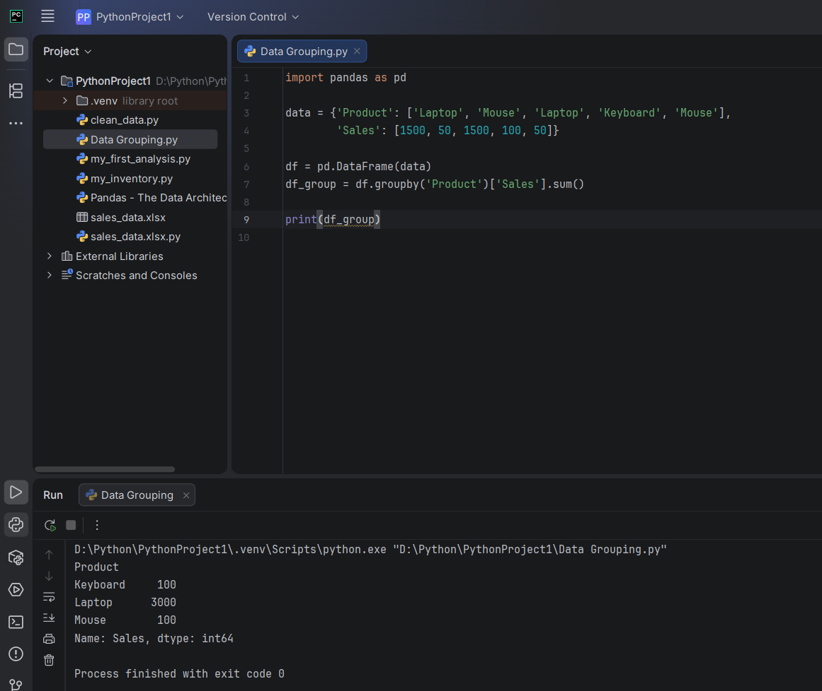

Teacher enakku rendu kelvi mudal kelvi df_group = df.groupby('Product')['Sales'].sum() inda line la enn product () inda bracket signlum Sales [] inda bracket signlum. mathadu enda picture la last la Name: sales , dttype: int64 endu irikkudu
Irshad, romba arumaiyaana kelvigal! Oru Data Analyst aavadharku, intha chinna vishayangalil thaan thelivaaga irukka vendum. Ungaloda kelvigalukku marubadiyum namoda "Child-friendly & Logical" method-la vilakkam tharugiren.
1. Kelvi: () vs [] - Intha brackets yen veru veru?
Python-il ovvoru bracket-ukkum oru mukkiyamaana artham undu.
Sign | Peyar | Enna Seiyum? (Logic)
() | Parentheses | Ithu "Order" koodukkum sign. Python-kku "Indha velaiyai sei" nu command panna idhai use panrom.
[] | Square Brackets | Ithu "Selection" sign. "Indha table-la irukkura indha specific column-ai mattum eduthu kudu" nu solla idhai use panrom.
Link & Connection:
- groupby('Product'): Inga ()-ai use panrom, yenna "Group sei" nu oru Order (Command) kodukkrom. Adhukkulla 'Product' nu kudukkum pothu, adhu "Endha column-ai base panni group panna?" nu purinjukkum.
- ['Sales']: Inga []-ai use panrom, yenna table-kulla pala column irukkum, adhil 'Sales' nu irukkura column-ai mattum select panna idhai use panrom.
2. Kelvi: "Name: Sales, dtype: int64" - Ithu enna solludhu?
Ithuthaan Python namma table-ai epadi "Math-ki" (Numerical analysis) ready panni vachirukkudhu nu sollura "Identification Tag".
- Name: Sales: Namoda table-oda column name 'Sales' nu irukkudhu, adhai Python confirm pannudhu.
- dtype: int64:
  - dtype = Data Type.
  - int = Integer (Number).
  - 64 = Python-oda memory size.
  - Artham: "Manager, intha column-la irukkura ellam numbers (Integer). Adhanala idhula namma math operations (sum, mean, etc.) panna mudiyum" nu Python solludhu.
🧠 Python Enna Yosikkum? (The Brain)
- Line 7-la: "Manager groupby nu ()-la command kuduthutaru. [] vachi 'Sales' column-ai select panni, ellathaiyum sum() panna solraru. Sari, namma Laptop-ai Laptop-oda kooti, Mouse-ai Mouse-oda kootuvom".
- Output kudukkum pothu: "Naan kooti mudichitaen. Ithu 'Sales' column, ithula irukkuradhu ellam numbers (int64), adhanala namma calculation success!" nu oru identification tag-oda output kudukkum.
⬅️ Left & Right Side Logic:
- df_group (Left): Ithu oru "Result container". Calculation mudinjadhum vandha table-ai inga store pannu.
- df.groupby('Product')['Sales'].sum() (Right): Ithu oru "Factory Process". Group panni, column-ai select panni, sum pannura mottha velaiyum inga nadakkudhu.
Teacher-oda Note:
- Python-kku () na Action (Sei), [] na Selection (Edu) nu gnyabagam vachukonga.
- dtype vandhu "Integer" (int64) nu irundha dhaan math velai nadakkum. Oruvelai "String" (text) nu irundha sum panna mudiyadhu.
Purinjiducha Irshad? Ippo namma oru "Full Data Analysis" panna ready! Adutha lesson-kku pōvallama?

